# Method Statement

This method statement gives instruction regarding change in code in VBA. The guide shows few simple change made in version v04.4 and methodical approach to up-versioning a file. This guide will not work on new column entry in any of the “Tables” object.

## Spreadsheet Hierarchy

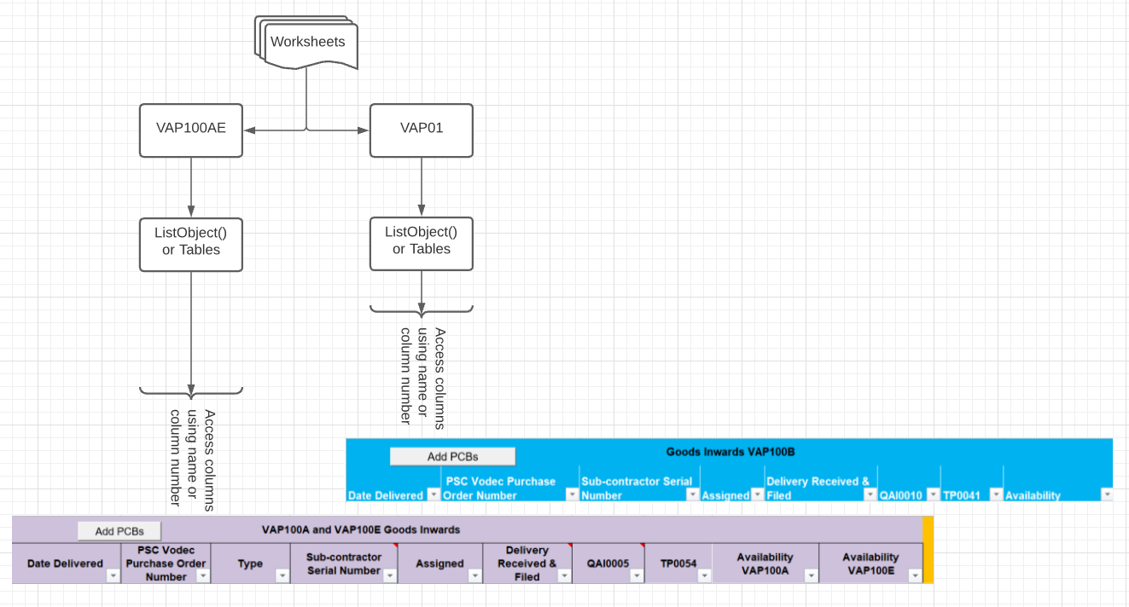

Figure 1 - Spreadsheet Hierarchy

The figure above shows overview of spreadsheet. The figure below represents modules, excel objects and forms associated with the workbook.

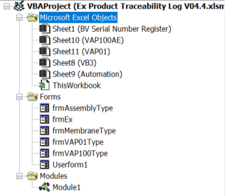

Figure 2 - VBA modules

This can be further divided into 3 units; Modules1, Sheet10 (VAP100AE), Sheet11 (VAP01).

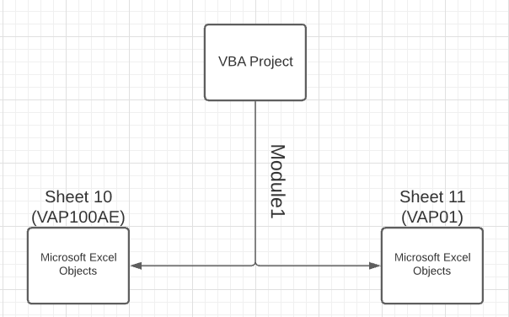

Figure 3 - VBA Project categories

Any amendments made anywhere within VAP Project has to be compared with previous version. The tool being used in this case is Notepad++ which allows different code to be compared and it highlights changes made. The following steps are to be considered when changes are made to the workbook.

1. Save a copy of existing version of spreadsheet
2. Open and disable *Autosave ()*
3. Copy original code - mainly Module, Sheets10 & 11 to different tabs on NP++
4. Identify and make necessary changes
5. Evaluate spreadsheet until satisfied
6. Copy modified file’s code and compare in NP++
7. Make changes to the original code in NP++
8. Compare against 3 files (Modules, Sheet10 & 11)
9. Open and transfer the modified code across to the original file
10. Enable *Autosave ()* and close the file

## Change in version with an example # 1

This example demonstrates an error found in VAP01 sheet, Assembly table “What was the delivery date?” to “Assembly date”.

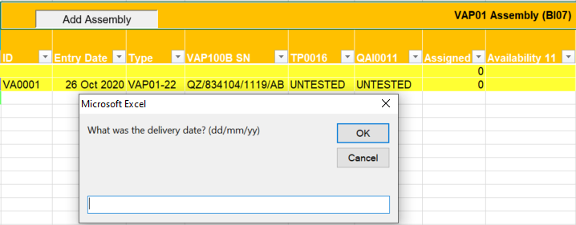

Figure 4 - Example #1

The error was traced in subroutine “*Add_VAP01_Assembly ()*”, which is located in Excel Object, Sheet11 (VAP01). 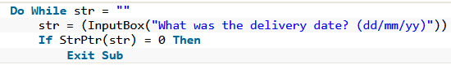

Figure 5 - Example #1 error identification

## Transferring code across without losing data

It is important not to delete or corrupt the data already provided in the excel sheet. After completing *Step 5* we can compare both codes on Notepad++.

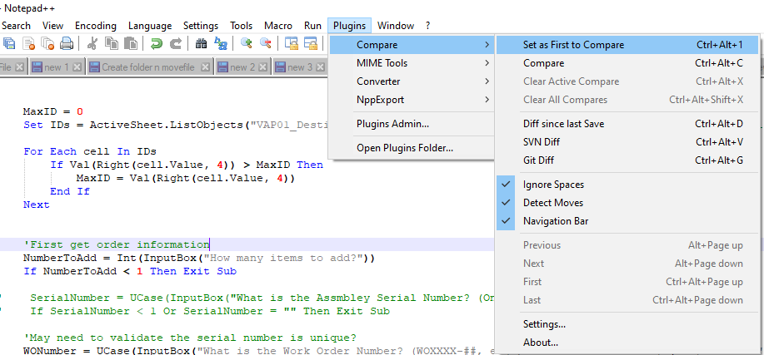

Figure 6 - Set file to compare against on NP++

The image below shows the changes made being highlighted on Notepad++

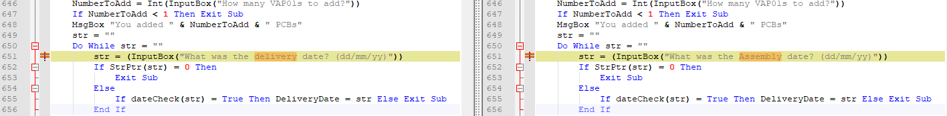

Figure 7 - NP++ highlight changes

Once the codes are compared, follow the Step 6 to Step 11.